BLY 121: GENERAL BIOLOGY
ECOLOGICAL ADAPTATION OF ANIMALS TO DIFFERENT ENVIRONMENTS

Learning Objective:
At the end of the lesson the students should be able to understand the various forms of ecological adaptations of animals in relation to different habitat types.

Introduction
Every organism has a unique ecosystem within which it lives. This ecosystem is its natural habitat. This is where the basic needs of the organism to survive are met: food, water, shelter from the weather and place to breed its young. All organisms need to adapt to their habitat to be able to survive.
This means adapting to be able to survive the climatic conditions of the ecosystem, predators, and other species that compete for the same food and space. An adaptation is a modification or change in the organism's body or behaviour that helps it to survive.
An animal's environment consists of many different things. The climate, the kinds of food plants that grow in it, other animals that may be predators or competitors- the animal must learn to adapt to each of these factors in order to survive. With increasing population growth and human activity that disturbs the natural habitat, animals must learn to adapt to these kind of threats as well.
Pisces
Pisces (fish) are aquatic vertebrates. They make up more than half of all vertebrate species. Most fish species are cold-blooded; however, one species, the opah (Lampris guttatus), is warm-blooded. Fish, the member of the Animalia Kingdom is classified into Phylum Chordata and Vertebrata Subphylum.

Morphology of Fish
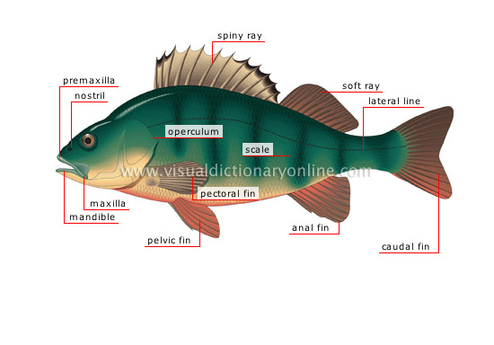
Figure 1: Morphology of fish
General Characteristics
Unlike mammals, fish are cold-blooded. This means that they do not maintain a constant internal body temperature; instead, their temperature is greatly influenced by their environment. True fish have a backbone and fins. Most also breathe with gills and have scales that cover their bodies. The general characteristics and adaptive features of fishes are outlined below.
Fins
The location, size and shape of fins are often associated with different body shapes. Fins serve many functions. Pectoral and pelvic fins are used for steering, balance and braking. Dorsal fins (located on the back) keep fish from rolling over in the water. The tail or caudal fin helps fish move in their habitats. Fast-swimming fish have narrow-forked tails that provide the thrust needed to speed through the water. Slower-swimming fish have a wide, square-shaped tail that helps them swim around rocks or reefs and catch prey.

Scales
These overlap in rows and help protect the fish against injuries and infection. In some species (for example, puffer fish) the skin covers the scales—creating a living surface. Their edges are jagged and sharp in some fish, and smooth and rounded in others. Over the scales, fish secrete a mucous covering to further protect against infection. The mucus traps and immobilizes bacteria and viruses, keeping them from entering the fish’s body. This covering also helps reduce friction, allowing the fish to move easily through the water.
Scales protect fishes and increase swimming efficiency. The type, size and number of scales can tell much about a fish’s lifestyle. Fast swimmers typically have fine scales (e.g., trout). Fish that don’t swim a lot and live in quiet water have more coarse scales (e.g., perch and ocean sunfish). Fish that are slow moving and bottom dwelling may have armor-like bony plates (e.g., seahorses, sturgeons, some catfishes).
Gills
In order to breathe underwater, fish have developed special organs called gills. The gills, found on the side of the fish just behind the head, contain thousands of capillaries, or tiny blood vessels. Water is constantly pumped over the gills, which filter the oxygen out of the water and directly into the fish’s blood. A gill cover, called the operculum, is a flexible bony plate that helps protect the sensitive gills. Gills are also important for excretion of waste products, particularly ammonia, from the fish’s bloodstream.
Swim Bladder
Fish have a unique internal organ known as the swim bladder or air bladder. It is usually found in the abdomen, and it helps fish move up or down in the water. By adjusting the amount of air in the bladder, fish can adjust the depth at which they float without continuously having to swim. In some fish, the swim bladder is also used to produce sounds. Members of the shark or ray family (elasmobranches) do not have a swim bladder.
Lateral Line
Most fishes have a line of specialized cells along their bodies. Sometimes the line appears like a series of tiny holes. This system is called a “lateral line” and it helps a fish to sense movement and vibration. This allows a fish to judge water depth, navigate through obstacles, orient itself in the water column and even detect prey and predators. Schooling fish use the lateral line to group themselves and maintain a school formation
Body Shape
The shape of a fish helps it hunt for prey, avoid predators and move through its habitat. A torpedo-shaped body increases a fish’s swimming speed. Most fish with this body shape live in open water and are excellent swimmers. Elongated fish may hide under or wrap around rocks or coral. Flatfish have flattened bodies. They lie on their sides on the seafloor with only their eyes protruding from the sand, hiding until their prey swim nearby.
Mouth
The design and location of a fish’s mouth indicates how it obtains food. If the mouth is on the underside of its body, it feeds on the bottom in sand or mud. When a fish’s upturned mouth is slanted toward the top of its body, it’s a surface feeder. If it has a big, wide mouth, it gulps its food. Fish with tiny teeth may nibble, while some shark species have rows of sharp teeth that bite and tear.
Eyes
Eye size depends on how and where a fish captures food. The position of a fish’s eyes identifies where it spends most of its time. When a fish has one eye on each side of its body, it usually swims in the water column and above the seafloor. If both eyes are on top or on one side of its body, it stays on or near the bottom. The eyes of some species look upward while others look downward. This helps them find prey or sense predators above or below their body.
Colors and Patterns
Stripes, spots and coloration provide fish camouflage that helps make them less noticeable to predators and prey. Some colors, such as yellow or orange, are a warning that the animal is poisonous. In addition, certain colors are invisible in the ocean depths, allowing the fish to blend in with its surroundings. False eyespots located on a fish’s body might confuse potential predators. Fish with countershading are dark on the top or dorsal side of their bodies and lighter underneath on the ventral side. This makes them more difficult for predators to see when looking down on them from the surface or looking up from the ocean depths.

Amphibians
Amphibians are ectothermic, tetrapod vertebrates of the class Amphibia. They inhabit a wide variety of habitats, with most species living within terrestrial, fossorial, arboreal or freshwater aquatic ecosystems. The living ones are frogs (including toads), salamanders (including newts) and caecilians.
Three primary orders of Amphibia within the Subclass Lissamphibia
- Caudata (Urodela) – Salamanders
- Anura (Salientia) - Frogs and toads
- Apoda (Gymnophiona) - Caecilians
Morphology
Modern amphibians are united by several unique traits. They typically have a moist skin and rely heavily on cutaneous (skin-surface) respiration. They possess a double-channeled hearing system, green rods in their retinas to discriminate hues, and pedicellate (two-part) teeth. Some of these traits may have also existed in extinct groups.
Members of the three extant orders differ markedly in their structural appearance. Frogs and toads are tailless and somewhat squat with long, powerful hind limbs modified for leaping. In contrast, caecilians are limbless, wormlike, and highly adapted for a burrowing existence. Salamanders and newts have tails and two pairs of limbs of roughly the same size; however, they are somewhat less specialized in body form than the other two orders.
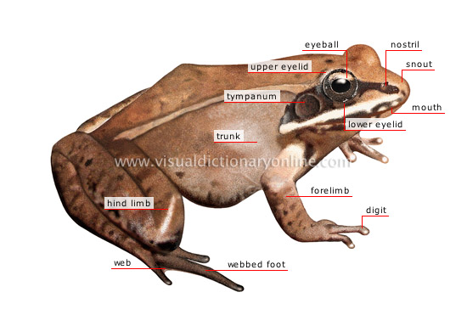
Figure 2: Morphology of an Amphibia
The general characteristics of amphibians are as follows;
- They are tetrapods (4 limbs). These facilitate moving about on land - these limbs evolved from the pectoral and pelvic fins
- Their skin is thin, soft, glandular and magid (lack scales except in the caecilians) - skin of caecilians with scales similar to those of fish
- They are ectothermic (they have limited ability to regulate their body temperature; their temperature thus depends on the ambient temperature
- They are both gill and lung breathers - usually gills in the larval stage, replaced by lungs in the adult; cutaneous respiration in many
- They have a three-chambered heart with two atria and one ventricle
- The skin is smooth, thin, hairless, porous and rarely scaled. The skin contains both mucus glands and poison glands
- Amphibians are the only vertebrates to undergo complete metamorphosis.
Adaptive Features
For amphibians, limbs and lungs were two of the most important adaptations as the former helped them move around without having to depend on the buoyancy of water, and latter replaced the gills to facilitate respiration.
While the bodies of various amphibian species are specially designed to help them swim, their powerful hind legs help them take large leaps and change direction with utmost ease when it comes to movement on the land. On the other hand, their typical color pattern - with dark body and light underside, plays a crucial role in camouflage in water as well as on the land.
The thin and moist skin that they sport is also an adaptation which facilitates processes like cutaneous respiration and osmosis in these species. Even though amphibians usually inhabit moist areas, the chances of water loss due to evaporation cannot be ruled out, and that's where their skin - which is specifically designed to minimize the amount of water loss, comes into play. Other than inhabiting moist environment, some species also resort to nocturnal lifestyle to minimize water loss. As amphibians are cold blooded animals, they cannot withstand cold environment and hence go into hibernation during the winter season.
Eyes positioned on the top of the head don't just facilitate a wide angle view for these species, but also help them stay in the water with their eyes just above the water surface. This proves to be an important adaptation when it comes to hunting as well as defense. Some amphibians release toxins from their skin which is yet another defense mechanism in some species of amphibians meant to keep predators at bay. At the same time, they sport a transparent eyelid which helps them see underwater with relative ease. While their eyes are considerably large, their mouths are even larger in proportion to their size - an adaptation which helps them catch and eat large prey with relative ease. Even the tongue of some amphibians is designed in such a manner that they can flick it out, grab the prey and pull it back to their mouth when hunting.

Arboreal
Arboreal animals are creatures which spend the majority of their lives in trees. They eat, sleep and play in the tree canopy. There are thousands of species that live in trees, including monkeys, koalas, possums, sloths, various rodents, parrots, chameleons, geckos, birds, tree snakes and a variety of insects. Many animals have evolved special adaptations to aid their arboreal lifestyles.
Morphology
Mammals
Sloths inhabit the forests of Central and South America and have special stomachs to help them obtain nutrients from leaves as well as curved claws to help them grip onto branches. The arboreal red squirrel, which inhabits both deciduous (trees with leaves) and coniferous (trees with needles) trees of North America have a bushy tail to help with balance and claws to help them grip. They eat cones, seeds and insects.
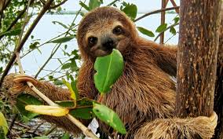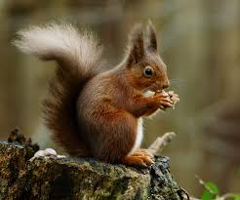
Plate 1: A Sloth and a North American Red Squirrel

Marsupials
The marsupial koalas are found in Australia. They survive off of eucalyptus trees. They have special paws and claws to help them climb and jump from tree to tree. Like the sloth, they have special adaptations to their stomach to help them obtain nutrients from a leaf-based diet.
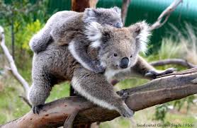
Plate 2: Koala

Birds
Another North American species, the pileated woodpecker, lives in coniferous and deciduous forests. It uses its beak to drill holes in trees where it builds its nests.
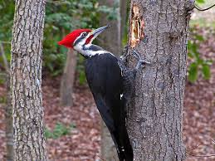
Plate 3: Pileated woodpecker
Adaptive Features of Arboreal Animals
Limbs and Tails
Many arboreal animals have elongated limbs that allow them to swing efficiently from branch to branch. Many monkey species show this anatomical adaptation. Several creatures have long tails (called prehensile tails) that can grasp branches and act as an extra limb. Spider monkeys, possums and chameleons are examples of animals that use their tails to help move and stabilize themselves in the tree canopy.
Feet and Claws
It is important that animals living in trees can grip well. Some arboreal animals, like squirrels, have ankle joints that are highly flexible, allowing the foot to point backwards so claws can hook into the tree bark when they are coming down the tree. Many arboreal animals have claws to grip into the trees, while others have adhesive pads like tree frogs and geckos. Primates have hairless fingertips for gripping, and chameleons have mitten-like feet to grasp branches.
Movement
Moving through trees presents different challenges to moving on the ground. Arboreal species tend to have a low center of mass to minimize the chance of toppling when climbing, and some have a crouched posture. They tend to have a diagonal sequence gait to maximize balance. Most arboreal mammals extend their limbs further forward and backward during movement, taking longer steps than their non-arboreal counterparts.

Size
The size of an arboreal animal influences the places it can go. Smaller animals can move through more cluttered habitat and can access smaller branches that will not take the weight of bigger animals. This can be an advantage in food gathering. Size and weight are also important for animals that use a gliding motion to move from tree to tree. Small species like bats often hang from branches, but so can larger animals like sloths, which achieve stability by hanging from their powerful claws.

